Firstly goto:

**www.stamfordhamvillageschool.org.uk**

as normal and click on the relevant link to go to the timetable.

When the lesson link appears using 2 fingers tap on the link at the same time (see pic)



This should bring up a menu:

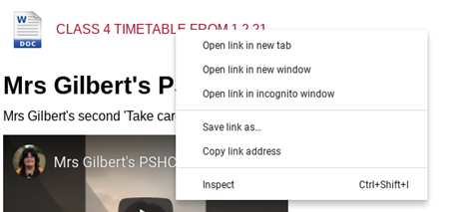

Select SAVE LINK AS and you will see

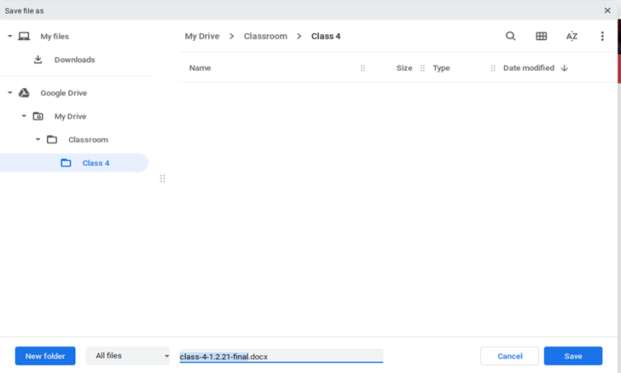

Remember what the file is called or rename it, the location in your google drive. Then Click on Save.

Now open Google Docs on your chromebook, (click launcher circle bottom left, and select docs)

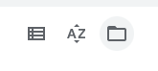

Select OPEN FILE PICKER

Keep Clicking CLASSROOM

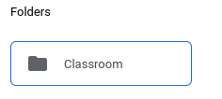

Then finally Click on the timetable to open it

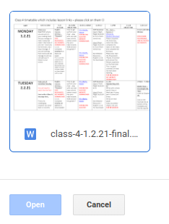

To open links within the timetable, again use 2 fingers and tap a highlighted link

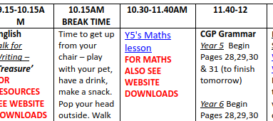

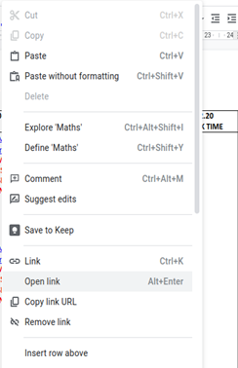 Then select OPEN LINK